# Task 1: Install and configure HDD

* Install a Hard Drive Partition HDD for dual boot

There is a 2TB Western Digital Green SATA hard drive with Windows 10 and Ubuntu 20.04 LTS installed and dual-booting in this computer. I installed Windows 10 first, then used the Disk Manager to shrink the Windows volume to make space for Linux.

The motherboard is an Asus M2N68-VM, with an Athlon dual-core CPU and an NVIDIA GeForce 7050 PV / nForce 630a IGP (Integrated Graphics Processor). This chipset has DVI, VGA, and HDMI ports, but does not allow for both the DVI port and the HMDI port to be used simultaneously, and I don’t have a monitor with VGA input, so I can connect only one monitor to the motherboard (see Task 4 for more detail on this).

# Task 2: Install Windows 10 and Ubuntu on HDD

* Install a network card
* Configure NIC to “Obtain an IP address automatically”

There is an Asus-brand WL-138g V2 wireless networking (802.11g) PCI card installed, plus onboard ethernet. The WiFi card is detected by Windows after several reboots and gets an IP automatically by default, but it was not detected by Ubuntu. To get it to work on Ubuntu, I had to connect via ethernet and manually install an extra package for the Broadcom BCM4318 controller chip using apt install commands in the bash shell/Terminal, after running lspci | grep -e NVIDIA to get the chipset details.

The next two pages show photos of the Windows 10 installation process.

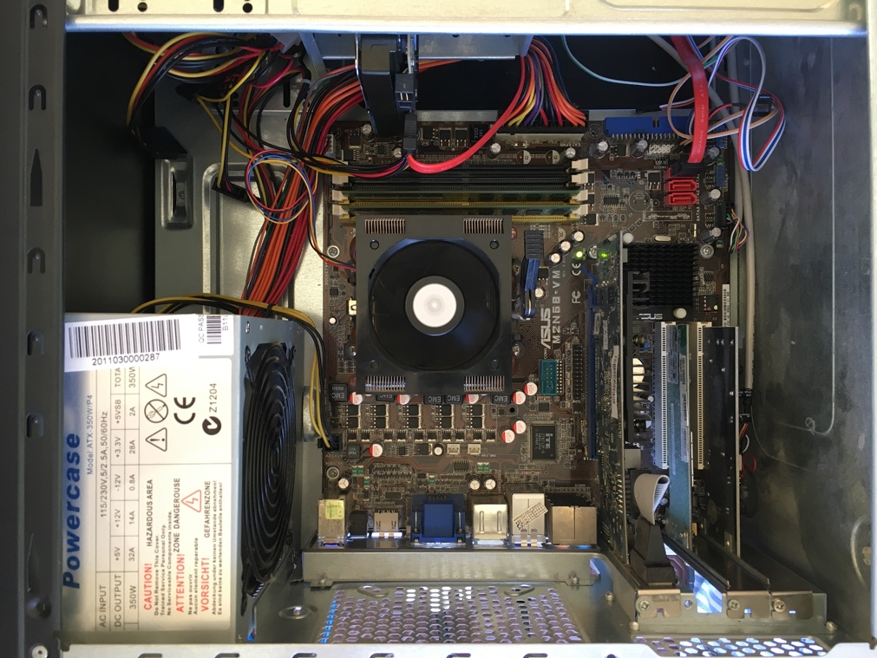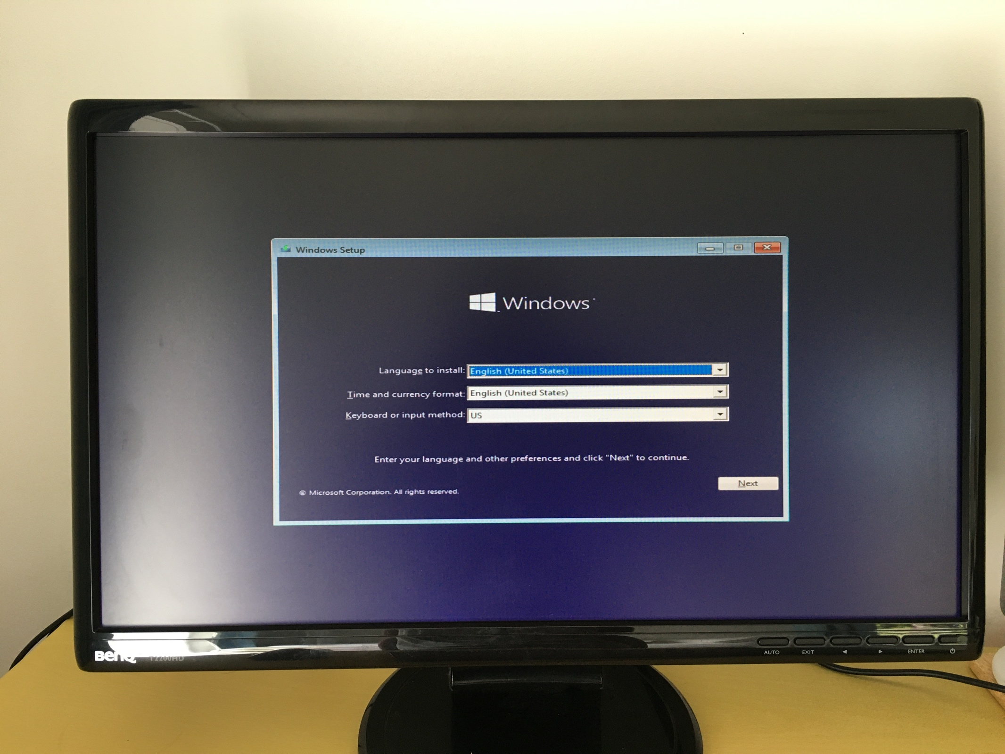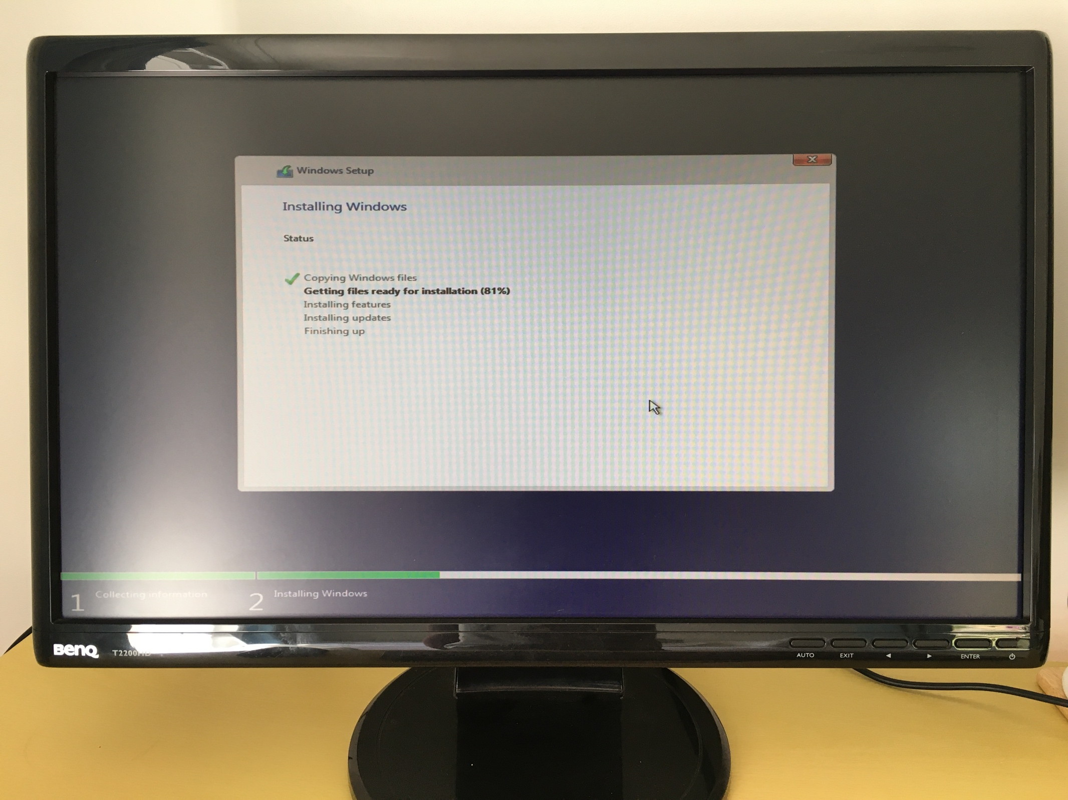

# Task 3: Install and configure a network card on Windows 10

* Configure newly installed NIC with an IP address and subnet mask (ask an instructor which one you can use)
* Configure PC to use two monitors. Primary desktop on your right extended to monitor on your left

Here is Windows 10 installed and working, connected to the Internet, and with balenaEtcher writing the Ubuntu 20.04 LTS ISO to a USB stick for installation:

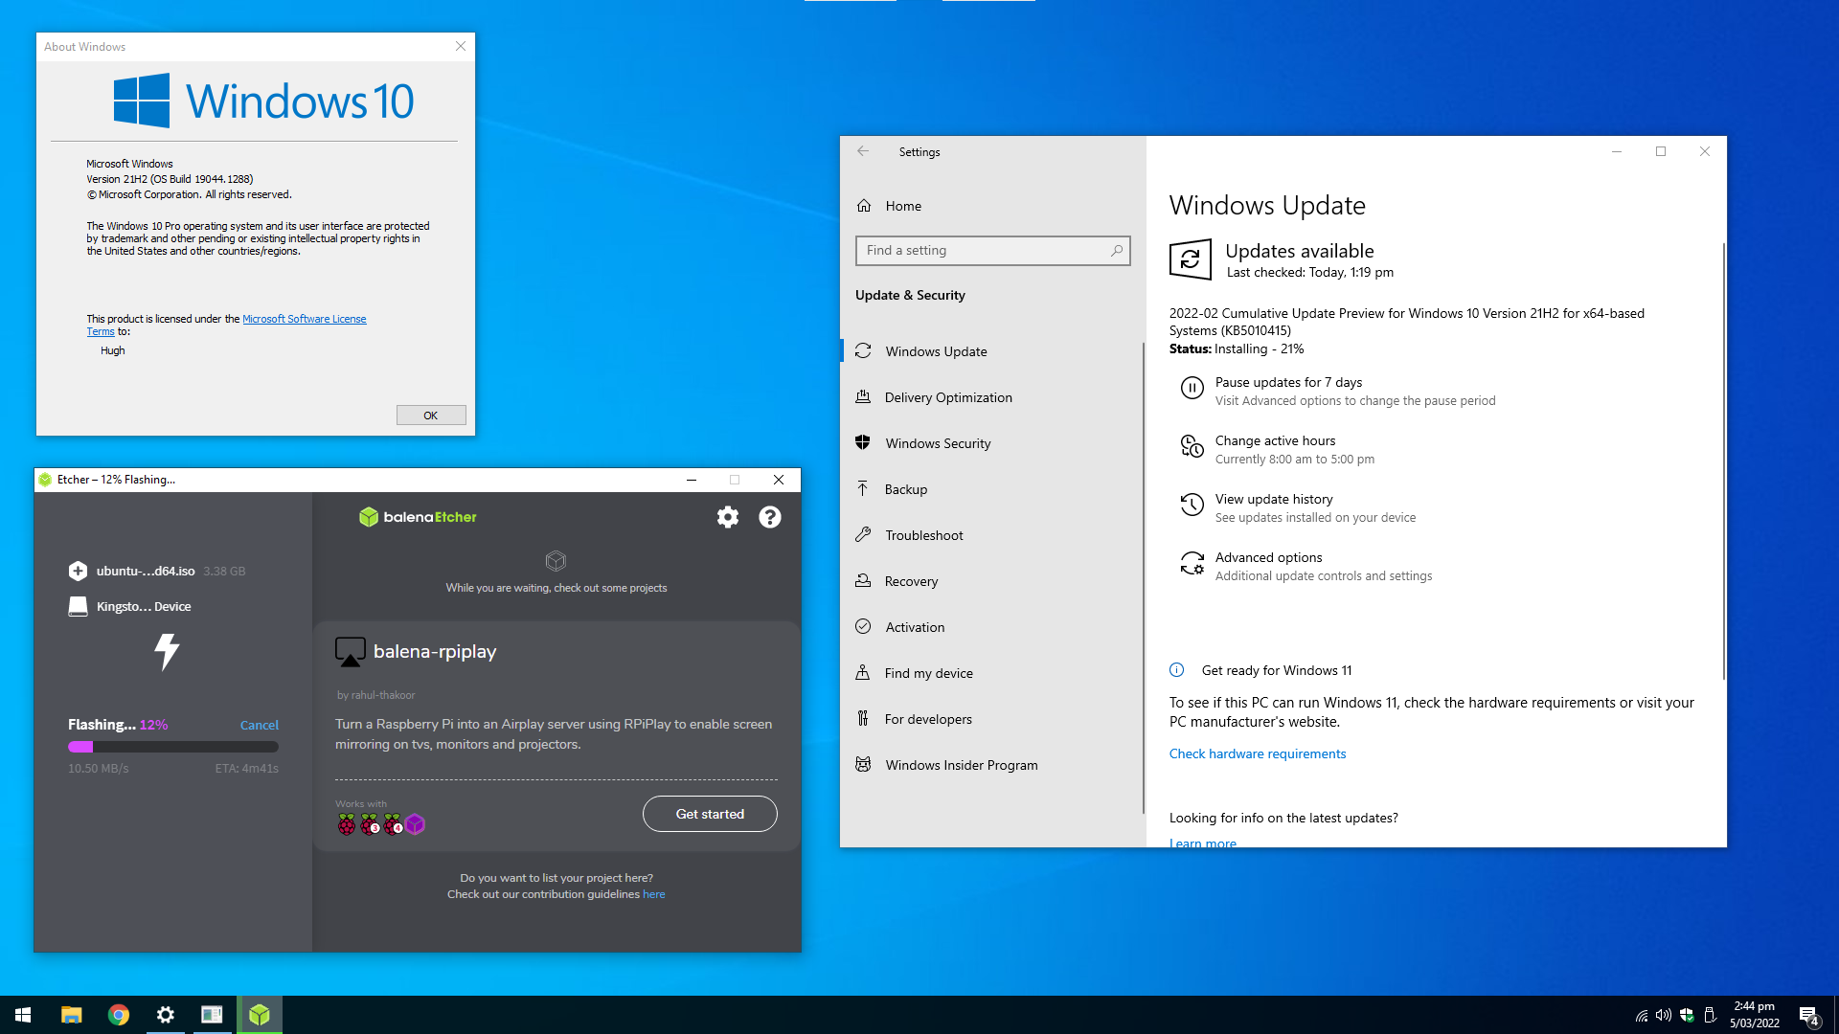

This screenshot shows the active WiFi connection, and would be where the subnet mask and IP address would be altered using the “Manual” drop-down option. Normally this is on automatic to obtain an IP by DHCP from my router – you can see this greyed-out underneath the “Edit IP settings” modal:

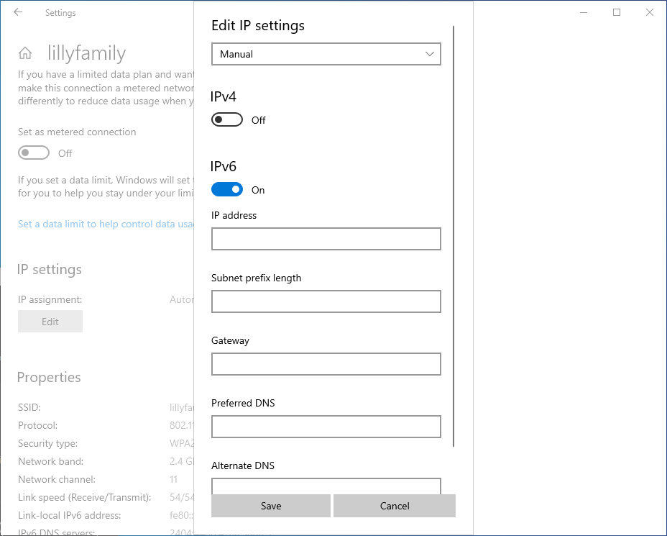

# Task 4: Install and configure a video graphics card

* Install video graphics card Install video graphic card drivers

As mentioned the IGP works OK on Windows 11. NVIDIA [ended support for this chipset last year](https://nvidia.custhelp.com/app/answers/detail/a_id/3142/~/support-timeframes-for-unix-legacy-gpu-releases), so the legacy 340.x series driver will not install on this iteration of Linux. I am therefore stuck on a 640 x 480-resolution output (to a single screen).

Here is proof Ubuntu is correctly installed, however, with the output of uname -a in a bash shell:

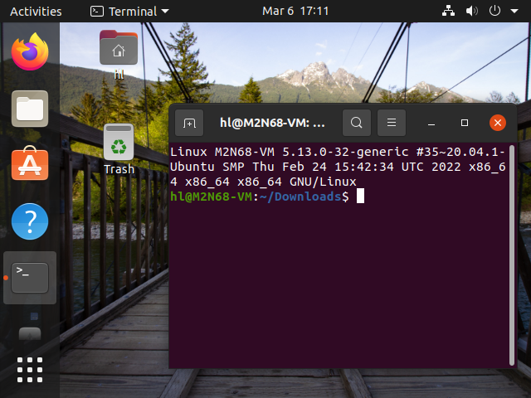

NB: There is a PCI graphics card (an AMD Radeon R640 HD) installed in the machine, but this card is not recognised by either OS (presumably due to its age) so I can’t attach an additional monitor to it, unfortunately. Previously with Windows 7, when this was my main computer c. 2007–2014, I had a dual-monitor setup with the primary monitor on the right, and the desktop extended to the left-side monitor, just as is requested in Task 3. I did not want to spend too much time working on getting this old PCI card to work, and from some searching I don’t think it is possible to get either OS to pick it up.